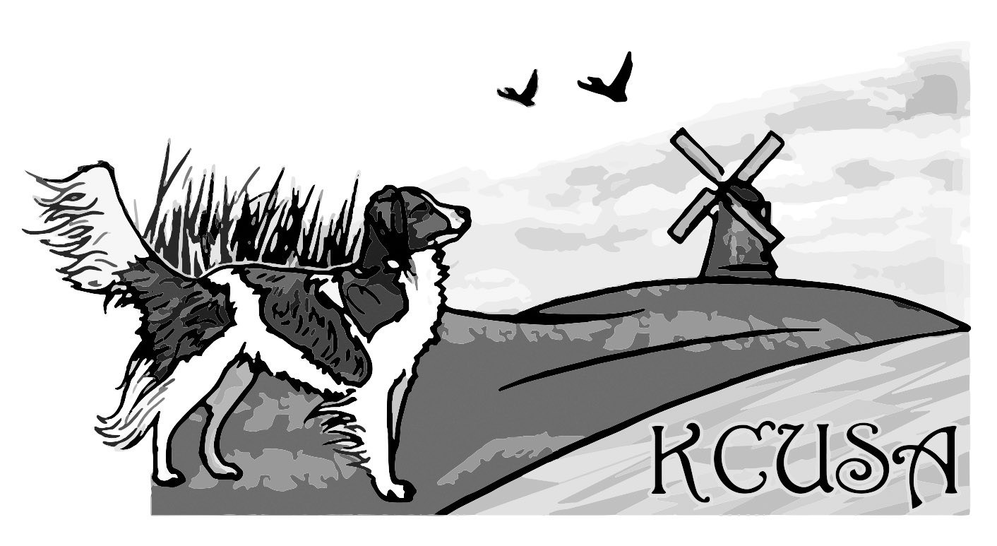
Nederlandse Kooikerhondje Club
of the
United States of America, Inc.

Litter Report Form
breeding@kooikerhondjeusa.org

Litter Visit Date:

Breeder:

Tel.:
Kennel Name:
Litter Date of Birth:
Number of Males ____ / Females ____ Number of Deceased:
Date:

Cesarean Section: Y / N
Necropsy (autopsy):

Sire: Registration Number:
Date of Birth:

Dam: Registration Number:
Date of Birth:

Number of Litters of Dam:

Address where puppies live:

Nutrition and puppy care practices:

Deworming date(s): Vaccination date(s):

Additional information for individual pups: Coat color and balance (plate / mantel)
Closure of bite Eye color (shape, visible membrane)
Head silhouette (too little / too much stop) Carriage and size of ears
Length and straightness of tail Umbilical hernia
Clean ears, eyes, nose, penis, vulva Behavior of the pup

Dam’s behavior to visitors:

Dam’s behavior to puppies:

Original to KCUSA
Copy to VHNK
Copy to the Breeder
Signature of Evaluator: _________________________ Signature of Breeder: ____________________________

Registered Name:

Male / Female Registration Number: Microchip Number:

Color:

Markings: (mantel, too much white, pirate)

Head shape: (head silhouette – too much or too little stop)

Bite: (scissor, overshot, undershot)

Eyes: (shape, color, visible membranes)

Ears: (carriage, size)

Bone:

Tail: (straightness and length)

Behavior:

Remarks / Pictures:

Insert photo of left side here Insert photo of head here (front view)

Insert photo of right side here Insert photo of back here

