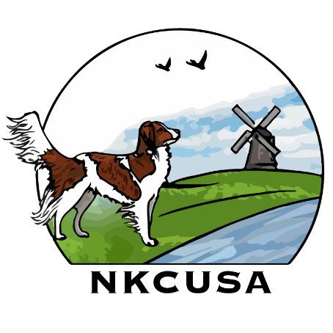
VERSATILTY AWARD WORKSHEET
Use this worksheet to record the titles your dog has earned and the number of venues.
Venues and Points

OBEDIENCE RALLY
BN- 2 RN- 2
PRE-NOV- 3 INTERMEDIATE- 3
CD- 4 RA- 4
GN,PREF OPEN- 5 RE- 5
CDX- 6 RM- 6
GO- 7 RAE- 8
PREF UTILITY- 8 RACH- 10
UD- 10
UDX- 12
OTCH- 14
POC- 13

AGILITY FAST CAT
ACT1- 1 BCAT- 1
ACT2- 2 DCAT- 2
NAP- 3 FCAT- 3
NA- 4
OAPNF- 5
OF- 7
PAX- 9
AX- 10
MX- 12
PACH- 13
MACH- 14

FIT DOG FLYBALL
FITB- 1 FDCH- 1
FITS- 2 FM- 2
FITG- 3 FMX- 3
FETCH IT FMCH- 4
FETCH IT NOV- 1 ONXY- 5
FETCH IT INT- 2
FETCH IT ADV- 3
FETCH IT RET- 4

BARN HUNT TRACKING
RAT1- 1 TD/TDU- 6
RATN- 2 TDX- 8
RATO- 3 VST- 8
RATS- 4 CT- 12
RATM- 5
RATCH- 6
RATCHX- 7

SCENTWORK THERAPY DOGS
2 NOV TITLES- 1 THDN- 1
2 ADV TITLES/SWN- 2 THD- 2
SWA- 4 THDA- 3
SWE- 6 THDX- 4
SWM- 8 THDD- 5

CONFORMATION TEMPERAMENT
CHAMPION- 5 CGC/STAR PUPPY- 1
GRAND CHAMPION- 10 CGCA, CGCU, FDC- 2

TRICK DOG SEARCH AND RESCUE
TKN- 1 SARW- 6
TKI- 2 SAR-U1- 6
TKA- 3 SAR-U2- 8

DOCK DIVING ( NADD)
NOVICE/JUNIOR- 2
SENIOR/MASTER- 3
NOV/JUNIOR ADVANCED- 4
SENIOR/MASTER ADVANCED- 5
NOV/JUNIOR EXCELLENT- 6
SENIOR/MASTER EXCELLENT- 7

